**PROJECT: Validation of the User Login.**

**Developer Name:** PUTTA SAIKUMAR

This document contains contents for:

* Project Description
* Flow of the Application
* Core concepts used in project
* Conclusions.

**1.Project Description:**

1.Creating a servlet-based web application that shows a login page and validates it.

2.The correct values are hard-coded.

3. On successful login, a dashboard page is shown.

4.The dashboard will provide a link for logging out. Incorrect logins need to be handled by showing an error message page.

**2.Application Flow:**

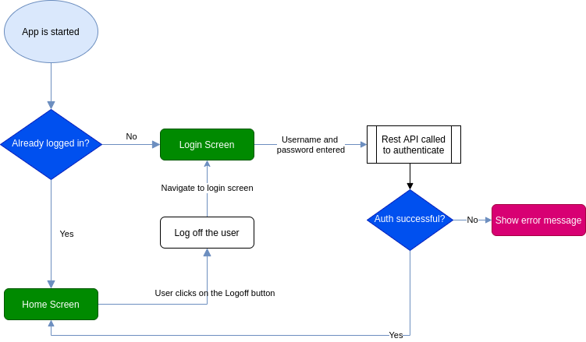

**4.Core concepts used in project:**

* Eclipse as the IDE
* Apache Tomcat as the web server
* HTML pages for the front end
* Servlets for backend processing

Conclusion:

* This project is designed for displaying the validation of user login